**Defect Report On Whats app Application**

**Name-Anurag Sanjay Jadhav**

**Roll No-14162**

**Div-A**

**Defect ID-DF01**

**Title**: Video Calls Fail to Connect with "Connecting" Status

**Description**:

* **Expected Behavior**: When initiating a video call, the call should connect and display the video feed of both participants.
* **Actual Behavior**: When initiating a video call, the call fails to connect and remains stuck on "Connecting..." indefinitely.

**Steps to Reproduce**:

1. Open WhatsApp.
2. Go to the chat of a contact who is online.
3. Tap the video call icon to start a video call.
4. Observe that the call status remains on "Connecting..." and never progresses.

**Screenshots or Screen Recordings**:

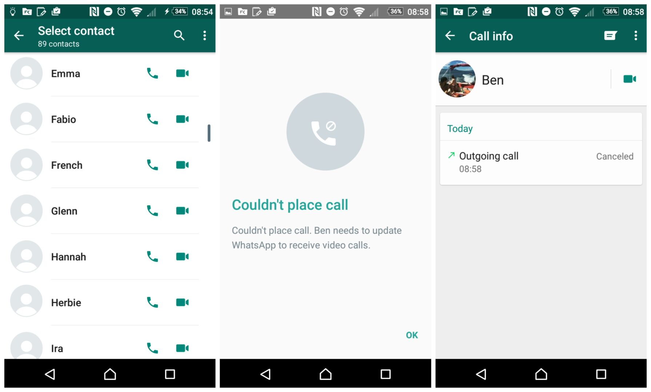

**Device and OS Information**:

* **Device**: iPhone 14 Pro
* **OS Version**: iOS 16.5
* **App Version**: WhatsApp 2.24.4

**Frequency of Occurrence**: The issue occurs every time a video call is initiated with any contact.

**Severity**: High - The inability to connect video calls significantly impacts communication.

**Additional Information**:

* The issue persists even when using both Wi-Fi and mobile data.
* Other users have reported similar issues in online forums.
* The problem started after updating the app to the latest version.